ReliefSync — UML Class Diagrams of Implemented Design Patterns
1. State
com.reliefsync.state
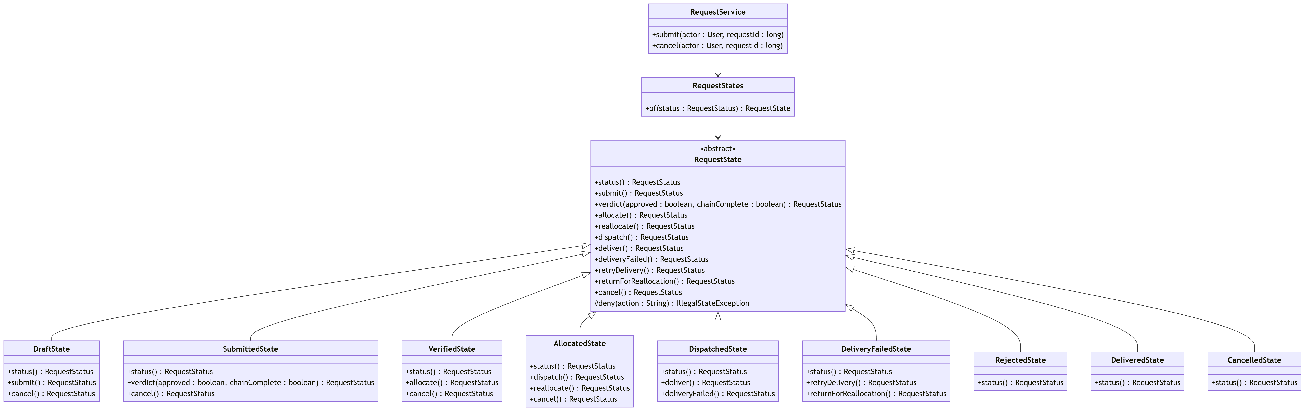

2. Chain of Responsibility
com.reliefsync.verification
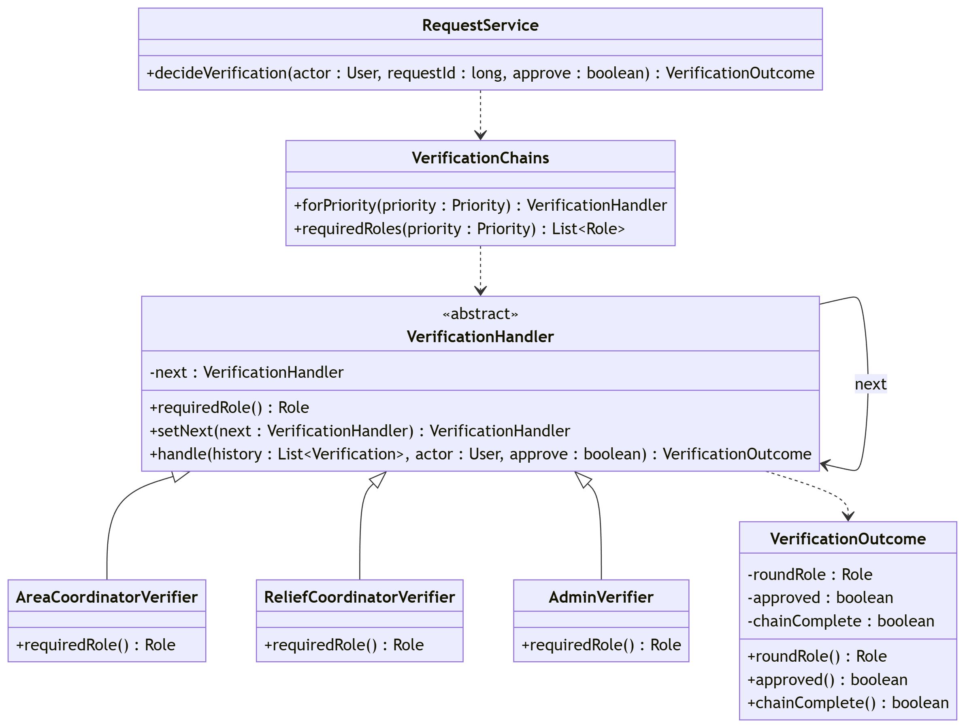

3. Strategy
com.reliefsync.strategy
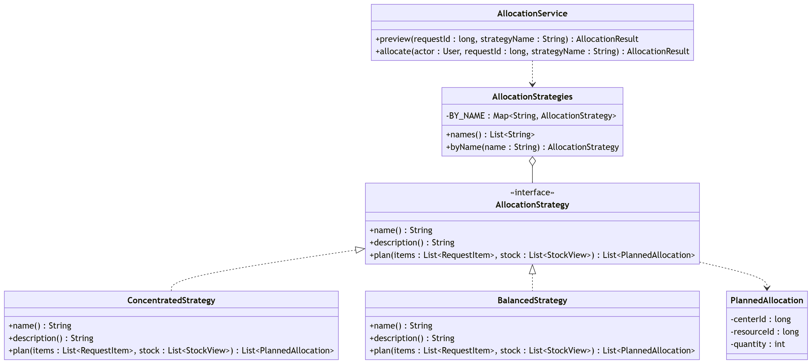

4. Observer
com.reliefsync.notification
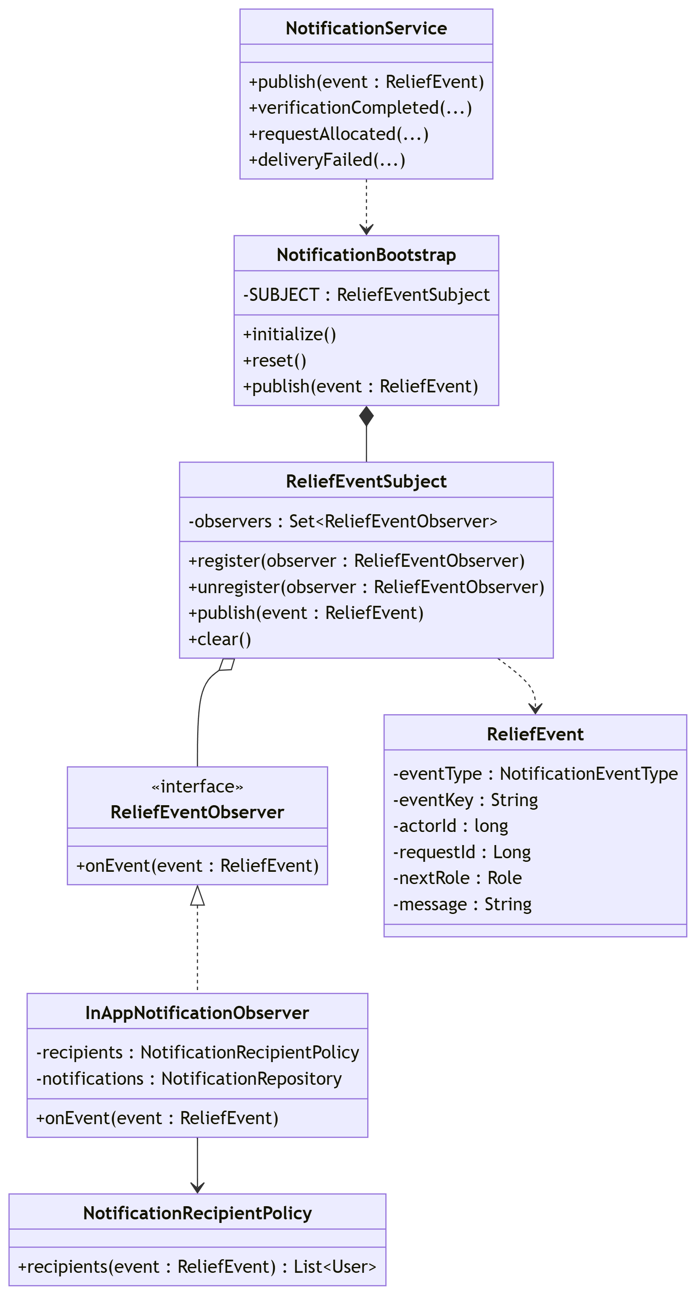

5. Facade
com.reliefsync.facade
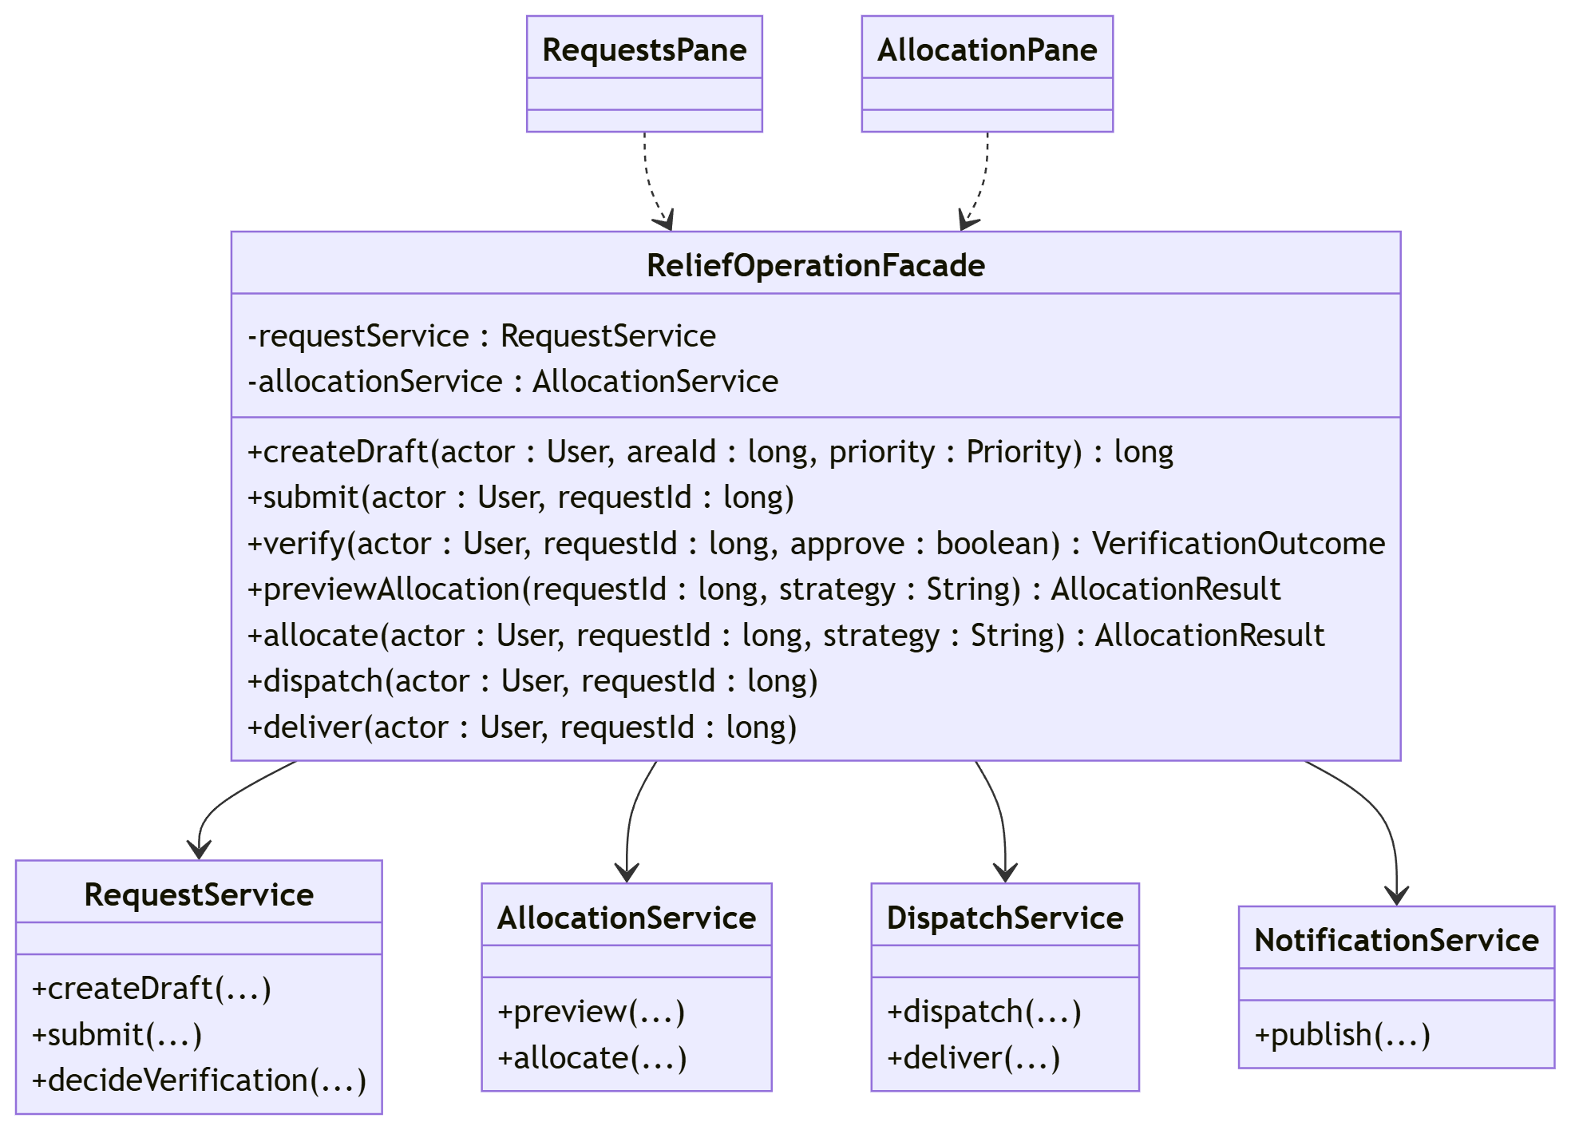

6. Singleton
com.reliefsync.db
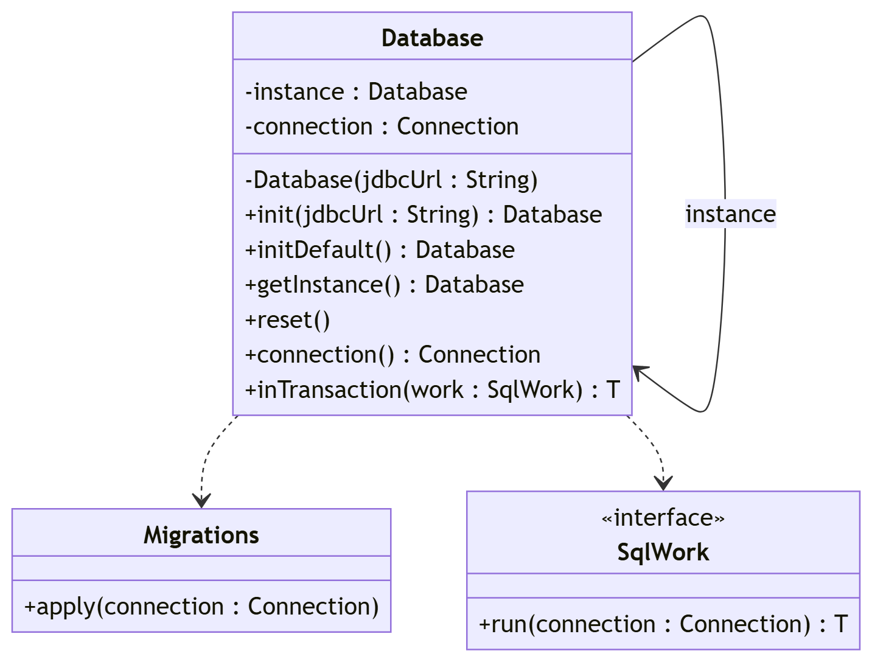

7. Repository
com.reliefsync.repository
